**1. What do you mean by cells in an excel sheet?**

**2. How can you restrict someone from copying a cell from your worksheet?**

**3. How to move or copy the worksheet into another workbook?**

**4. Which key is used as a shortcut for opening a new window document?**

**5. What are the things that we can notice after opening the Excel interface?**

**6. When to use a relative cell reference in excel?**

**A1.** A cell is **the intersection of a row and a column**. It's where a row and column meet. Columns are identified by letters (A, B, C), while rows are identified by numbers (1, 2, 3).

**A2.** 1. In your Excel file, select the worksheet tab that you want to protect.

2. Select the cells that others can edit.

3. Right-click anywhere in the sheet and select Format Cells (or use Ctrl+1, or Command+1 on the Mac), and then go to the Protection tab and clear Locked.

**A3**. **On the Window menu, click the workbook that contains the sheet that you want to move.** Click the sheet that you want to copy to the other workbook.

On the Edit menu, click Sheet > Move or Copy Sheet. On the To book menu, click the workbook that you want to move the sheet to.

**A4**.  **Ctrl+N**.

**A5.** Title bar. The title bar displays both the name of the application and the name of the spreadsheet.

Menu bar. ...

Column headings. ...

Row headings. ...

Name box. ...

Formula bar. ...

Cell. ...

Navigation buttons and sheet tabs.

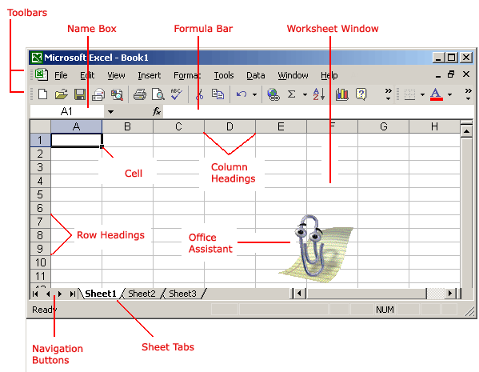

**A6**. Relative references are especially convenient **whenever you need to repeat the same calculation across multiple rows or columns**.